## Cluster setup

To manage costs:

* Switch to standard cluster
* Select use a setup guide.. These use low cost resources:
  + 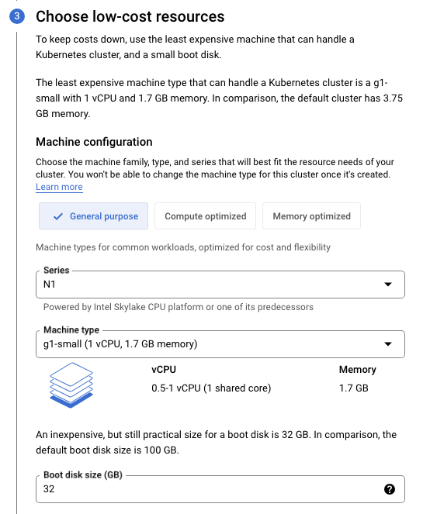
  + As part of this option - can also select to use a cluster autoscaler - which creates and deletes nodes as we require.. - for now, don’t pick this! Will go with standard 3 nodes!
* Can enable logging and cloud monitoring on system level - not sure what it gives, but can be useful potentially
  + 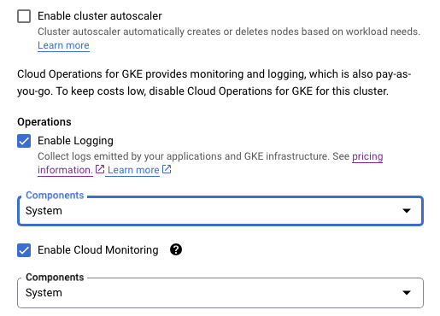
* Summary of cluster:
  + 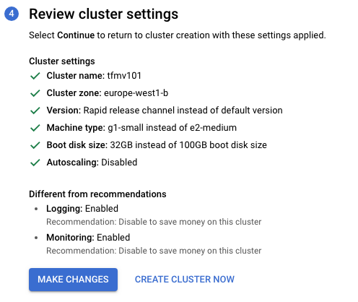

When cluster creating we can enable a managed prometheus:



* Can be useful for metrics!

Gives a status similar to the following:

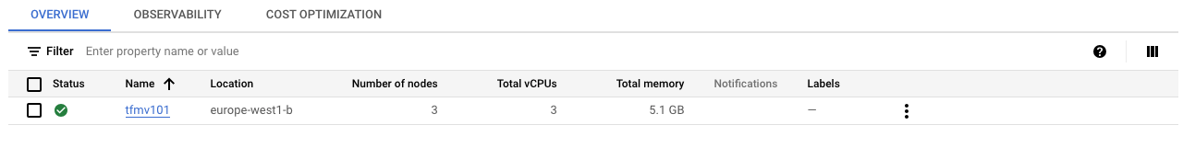

Need to keep resources and requests conscious of this setup.. Or specify an autoscaler but controlled if required for many HTTP requests!

## Cluster Connect

To connect to new cluster, need to create a new profile on gcloud CLI:

* gcloud cli (and then follow options)
* Then take the cluster connect string from Cluster connect in GCP console
* Should then be able to list pods via kubectl etc